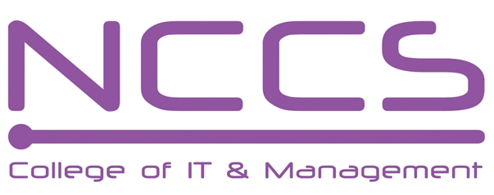
National College of Computer Studies
(NCCS-College of IT & Management)
Final Examination (2021)
BSc.CSIT/First Semester/ CSC-101 : Introduction to Information Technology

Candidates are required to answer the questions in their own words as far as practicable.

Full Marks: 60
Pass Marks: 30
Time: 3 Hours
Set A

Long Questions:
Attempt any two Questions: [2×10=20]
- What is communication protocol? Discuss the OSI model with its layers.
- What is database managment system? What are the benefits of using database processing over file processing? Discuss different types of DBMS.
- What is operating system and how does operating system work? Explain different functions of operating system.
Short Questions:
Attempt any eight questions [8×5=40]
- Compare third and fourth generation computer?
- Compare internet, intranet and extranet.
- Explain briefly about optical input devices.
- What is instruction set? Explain about instruction cycle.
- What is modulation? What are the advantages of modulation?
- What is system software? Explain briefly about its different types
- Explain briefly about different binary coding schemes.
- What is data mining? Explain briefly about different components of data ware house.
- What is cryptography? explain about digital signature.
- What is big data? Why big data is necessary?

********

